**MODEL CODE**

**OF PRACTICE**



**ODISHA MINING CORPORATION LTD.**

**KODINGAMALI BAUXITE MINE**

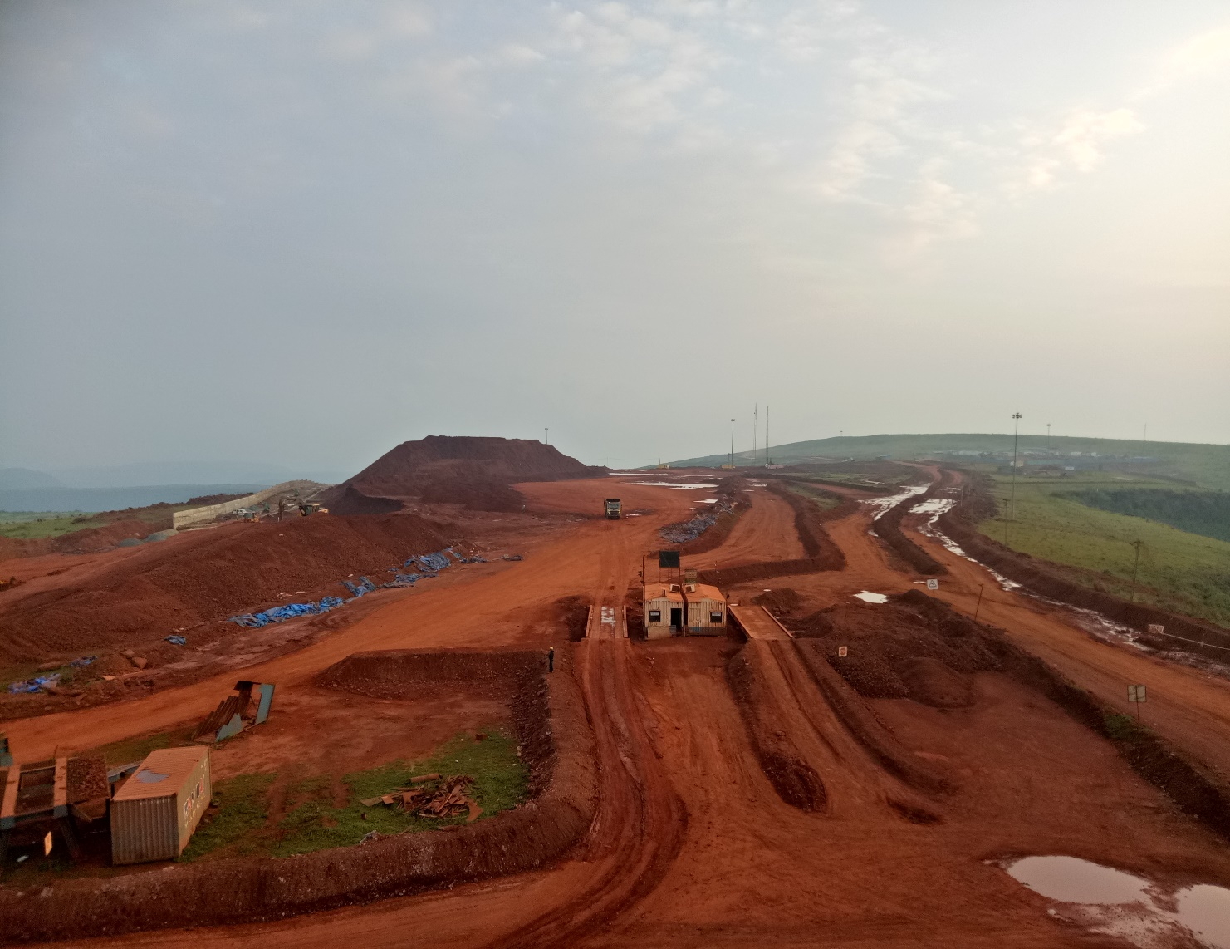

**Authorized By**

**Procedure**

1. Only authorized personnel are allowed to work.
2. Ensure that all required PPE is in good condition and correctly fitted.
3. Ensure the use of correct tool is used for the correct job.
4. All the tools want to be kept in good condition.
5. Inspect the tool to be used if any defects found it should be tagged as out of Service.
6. Inspect each chain or sling for cuts, nicks, bent links, bent hooks, etc., before each use. If in doubt, don't use it.
7. Determine the weight of the object or load prior to a lift to ensure the lifting equipment operates within its capabilities.
8. Estimate the center of gravity or point of balance, the lifting device should be positioned on the determined center of gravity.
9. Do not take the risk with your back. Use lifting and moving devices to help you with your work. When lifting, always do it with your legs, not with your back.
10. Use slings of proper reach. Never shorten a line by twisting or knotting. With chain slings, never use bolts or nuts.
11. Do not stand under or allow anyone else to stand under equipment that is being hoisted.
12. Ensure that the signaler is properly identified and understands techniques of proper signaling.
13. Ensure the free spaces around the equipment’s being in use.